# Introduction

Through this experiment a nonlinear modulation technique where the modulating signal varies the instantaneous frequency of the carrier wave, Frequency Modulation, was studied, observed and analyzed. Through the lab various methods for estimating the bandwidth of a Single-Tone Modulated FM signals, for both the Narrowband as well as the Wideband FM signals, was also studied. The methods included Carson’s rule, 1% rule and Universal curve corresponding to the 1-% rule. The effects of lock and pull-in range were also observed. Through the lab many other topics were touched on such as the modulation index and frequency sensitivity parameter, the rms values of the FM signal, the bandwidth of the FM signals, the phenomenon of few narrow band frequency positions being produced when the input frequency was increased towards the negative pull-in frequency range.

# Theory

There are many formulas retrieved from the appendix in order to calculate the modulation index in various ways and there are also formulae used to calculate modulation index, frequency sensitivity parameter and the bandwidth of the FM signal. The main theory behind this lab is the frequency modulation and demodulation of signals using different techniques. Some techniques lie in the time domain where others are in the frequency domain. The operational properties of a Phase Locked Loop were used to demodulate the signals. Finally, the power of the $φ_{FM}\left(t\right)$ is contained within a finite bandwidth. Below are the formulae used throughout the experiment.   
The FM signal for a single tone modulating signal $m\left(t\right)=A_{m}cosω_{m}t$ would have the equation as:

$φ_{FM}(t)=A_{c}cos⁡(ω_{c}t+K_{f}\int_{0}^{t}{m\left(λ\right)dλ}=A_{c}cos⁡(ω_{c}t+βsinω_{m}t)$ (Eq.1)

Where $∆ f=K_{f}A_{m}/(2π)$, is the frequency deviation parameter and β is the modulation index of the FM signal.

$β= ∆f/f_{m}$ (Eq.2)

Upon expanding the Real part of the FM signal, the equation now becomes $Re\{A_{c}e^{jβsinω_{m}t}e^{jω_{c}t}\}$. It is seen that the complex exponential $e^{jβsinω_{m}t}$ is periodic and thus expands into the Fourier series:

$e^{jβsinω_{m}t}=\sum_{n=-∞}^{∞}{C_{n}e^{jnω_{m}t}}$ (Eq.3)

$C_{n}=\frac{ω_{m}}{2π}\int_{-π/ω_{m}}^{π/ω_{m}}{e^{jβsinω_{m}t}}e^{-jnω_{m}t}dt=J_{n}(β)$ (Eq.4)

where, $J_{n}(β)$ is the Bessel function of the 1st kind, order n and argument β. Implementing equation Eq.3 and Eq.4, $φ_{FM}(t)$ can be expressed as:

$φ_{FM}\left(t\right)=\sum_{n}^{1}{J_{n}\left(β\right)cos⁡(ω_{c}+nω_{m})t}$ (Eq.5)

Subsequently, since the function is now in a suitable form to compute the spectrum, the equation for the former is as follows:

$Φ_{FM}\left(f\right)=\frac{A_{c}}{2}\sum_{n}^{1}{J_{n}\left(β\right)[δ\left(f-\left(f_{c}+nf_{m}\right)\right)+δ\left(f+\left(f_{c}+nf_{m}\right)\right)}]$ (Eq.6)

It is to be noted that since the modulation index β determines Jn(β), this then determines the shape of the ΦFM(f). This leads to the following observations:

1. Magnitude of the spectral component at fc+nfm is Ac|Jn(β)|/2
2. |Jn(β)| decreases with increasing β (assuming n is fixed).
3. |Jn(β)| decreases with increasing n (assuming β is fixed).

For a Narrowband FM with β ≤ 0.3, the equation for the $φ_{FM}\left(t\right)$ becomes:

$φ_{FM}\left(t\right)≈ A_{c}cosω_{c}t+ A_{c}J_{1}\left(β\right)cos(ω_{c}+ω_{m})t+ A_{c}J_{-1}\left(β\right)cos(ω_{c}-ω_{m})t$ (Eq.7)

Therefore, the bandwidth is as follows:

$B_{FM}≈ 2f_{m}$ (Eq.8)

For a Wideband FM with β ≤ 0.3, the determination of the bandwidth is dependant upon the number of significant sidebands. Using the 1-% rule, the sideband index *n* is determined such as:

$A_{c}\left|J_{n}\left(β\right)\right|> {10}^{-2}A_{c}J_{0}(0)$ (Eq.9)

With nmax being the largest value of the sideband index and $\left|J_{n}\left(β\right)\right|> {10}^{-2}$, the nmax is determined from a table of values of Bessel function. With nmax determined, bandwidth is then estimated as:

$B_{FM}≈ 2{n_{max}f}_{m}$ (Eq.10)

Subsequently, the x-% rule can also be applied by implementing the Universal Curve. This is done by normalizing the results derived from the Bessel function tables with respect to the frequency deviation $∆f$ and then plotting it as a function of $β$. The bandwidth *B*FM is then estimated using the modulation index $β$ and the frequency deviation $∆f$ parameters.

Procedure:

### Part A: Characteristics of FM Signals

1. The modulating signal was connected to Channel 1 and the FM signal was connected to Channel 2 of the oscilloscope. The setting described in Part-A/B Setup were used and the modulating and FM signals were displayed. The one-sided rms spectrum of the FM signal was displayed on the oscilloscope using the modulating signal as the trigger.
2. The amplitude of the modulating signal was increased from 2 Vpp to 10 Vpp and the corresponding changes in the spectrum of the FM signal were observed.
3. The amplitude was reset to 2 Vpp and the frequency of the modulating signal was gradually reduced from 1 KHz to 100 Hz and the corresponding changes in the spectrum of the FM signal were observed.
4. The amplitude and the frequency were then set to 2 Vpp and 1 kHz respectively. The resulting one-sided rms values of the spectrum were recorded. The parameters of the modulating signal were then changed to 1 Vpp and 500 Hz. Similarly, the resulting one-sided rms values of the spectrum were recorded.

### Part B: Modulation Index

1. The parameters of the modulating signal were set to roughly 0 V and 1 kHz. The amplitude was then gradually increased until a spectral null at carrier frequency 10 kHz was observed. The corresponding values of the amplitudes of the modulating signal were recorded and the modulation index $β$ and the frequency sensitivity parameter $K_{f}$ and were determined.
2. The amplitude of the modulating signal was increased until a second spectral null was spotted at the carrier frequency. The corresponding values of the amplitudes of the modulating signal were recorded and the modulation index $β$ and the frequency sensitivity parameter $K_{f}$ and were determined.
3. The frequency of the modulating signal was set at 1 kHz and the frequency sensitivity parameter $K_{f}=3.45 kHz/V$ and the value of the amplitude of the modulating signal was calculated to achieve the modulation index $β=0.2, 1 \& 5.$
4. With the modulating signal amplitude at the recorded value, the modulation index $β=0.2$ was achieved. The magnitudes of several spectral components of one sided rms spectrum were measured and recorded, ignoring the spectral components with magnitude less than 10 mV.
5. Step 4 was repeated for modulation index $β=1 \& 5.$

### Part C: Operational Characteristics of Phase Locked Loop

1. The connections were setup based on the instructions and the free running of the VCO was set to 10 kHz. The DMM was used to measure the DC voltage Ve. The measured voltage was labelled as Vref and represented the VCO input when the PLL entered the free-running mode.
2. FG1 was reconnected to the terminal of the PLL and as adjusted to generate $v_{i}\left(t\right)= A_{i}cos2πf_{i}t$ with *fi* = 4 kHz and *Ai* = 2 Vpp. Channel 1 was connected to vi(t) and channel 2 was connected to vo(t). With vi(t) as the trigger source, the traces synchronized when the PLL was in lock condition.

The input frequency *fi* was gradually increased and the *f-p* frequency was determined at which the traces synchronized. The *f-p* defined the lower edge of the of the pull-in range of the PLL. With the PLL in locked condition, the DC voltage *Ve* was measured at the DEMout terminal of the PLL module.

1. The input frequency *fi* ­was increased in 1 kHz increments. As the PLL was in locked condition, for each measure of *fi* the DC value ve and phase angle vo(t) with respect to vi(t) was calculated. The frequency at which the PLL could no longer track, *fi* was recorded. The upper edge of the lock range was defined by *fL+*.
2. The *fi* was set at 16 kHz, which was then gradually decreased and the *fp+* was determined when vi(t) and vo(t) synchronized. With the *fc+* being defined as the upper range of the pull-in range of PLL, *fi* was decreased in 1 kHz decrements. As the PLL was in locked condition, for each measure of *fi* the DC value ve and phase angle vo(t) with respect to vi(t) was calculated. The frequency at which the PLL could no longer track, *fi* was recorded. The lower edge of the lock range was defined by *fL-*.

### Part D: Demodulation of FM Signals

1. This was a step that was asked of us not to perform due to lack of equipment and information provided during the lab session, hence the TA asked us to skip this bit. The instructions, however, went as follows. Since the lowpass filter module smoothed out the demodulated signal ve(t), the -3db frequency of the lowpass filter was set at 1 kHz.
2. With the connection made as per the instructions in the lab manual the FG1 was adjusted to output a single tone modulating signal with frequency 100 Hz and amplitude 2 Vpp.

The FG2 was adjusted to generate an FM signal with amplitude 2 Vpp and carrier frequency 10 kHz. The free running frequency of the VCO was set to 10 kHz and the modulating signal and the lowpass filtered demodulated signal were displayed on the oscilloscope. Channel 2 was then switched to AC-coupled mode and the frequency of the modulating signal was changed to verify that the PLL could successfully extract the modulating signal from the FM signal.

1. The system was then reconfigured as per the instructions in the lab manual. The modulating signal on the Simulink scope and the filtered demodulated signal were observed. The success of the PLL in demodulating the FM signal was the verified.
2. The FM signal was to be connected to the oscilloscope and the spectrum was to be displayed. After changing the span, center and v rms parameters of the spectrum analyzer, the dynamic structure of ΦFM(f) and how the FM signal bandwidth changed as a function of the amplitude of the audio signal was observed.

# List of Instruments

* Agilent DSO-X 2002A digital storage oscilloscope with waveform generations and spectrum analyzer options
* GW Instek GFG-8216A function generator
* Hewlett Packard 33120A function/arbitrary waveform generator
* PLL module based on LM565C chip
* Lowpass filter module
* Agilent E3603A triple output DC power supply
* Computer with Linux operating system
* MATLAB/Simulink 2014B

**Discussion:**

**Problem B1: Tabulated Results are seen above with calculated results.** The above tables show the different methods of amplitude modulation and the four different ways of calculating the modulation index of a given signal. The first two methods are in the time domain where as the latter two are in the frequency domain. The tables also show the relationship between the amplitude and the modulation index. As the amplitude of the modulating signal m(t) was increased the modulation index also increased. It can also be seen that the modulation index mimics the amplitude of the signal, in other words when the amplitude is 13 volts peak to peak the modulation is 1.3 and this is seen throughout for all the amplitudes used. For the most part this is the case and all the values are very close to what is expected however the skewed results may be a result of rounding errors during calculation and reading errors when measuring the different parameters needed to calculate the modulation index.

**Problem B2:** The modulation index (μ) can be found most easily and accurately found because of the flexibility and accuracy given by the trapezoidal display in this method.  Through experimental calculations it was found that this gave the most accurate results in comparison to what was expected. The Am and Ac can be easily determined the modulation index whether it was less than, equal to or greater than 1. Method 1 can also be accessible as it can also determine the modulation index for the lower, middle and higher points of the modulation index which was determined by the

**Problem B3:**

Table 5: Calculations for Carrier and Sideband Power using Method 3.

|  |  |  |  |  |
| --- | --- | --- | --- | --- |
| m(t) | AC | Am | PC[KW] | PS[KW] |
| 4 | 94.73 | 50.21 | 4.487 | 0.630 |
| 5 | 95.61 | 53.54 | 4.571 | 0.716 |
| 6 | 94.73 | 63.47 | 4.487 | 1.000 |
| 8 | 95.61 | 82.22 | 4.571 | 1.690 |
| 10 | 95.17 | 95.17 | 4.529 | 2.264 |
| 11 | 97.03 | 112.55 | 4.707 | 3.167 |
| 12 | 96.34 | 112.72 | 4.641 | 3.176 |
| 13 | 96.34 | 122.35 | 4.641 | 3.742 |

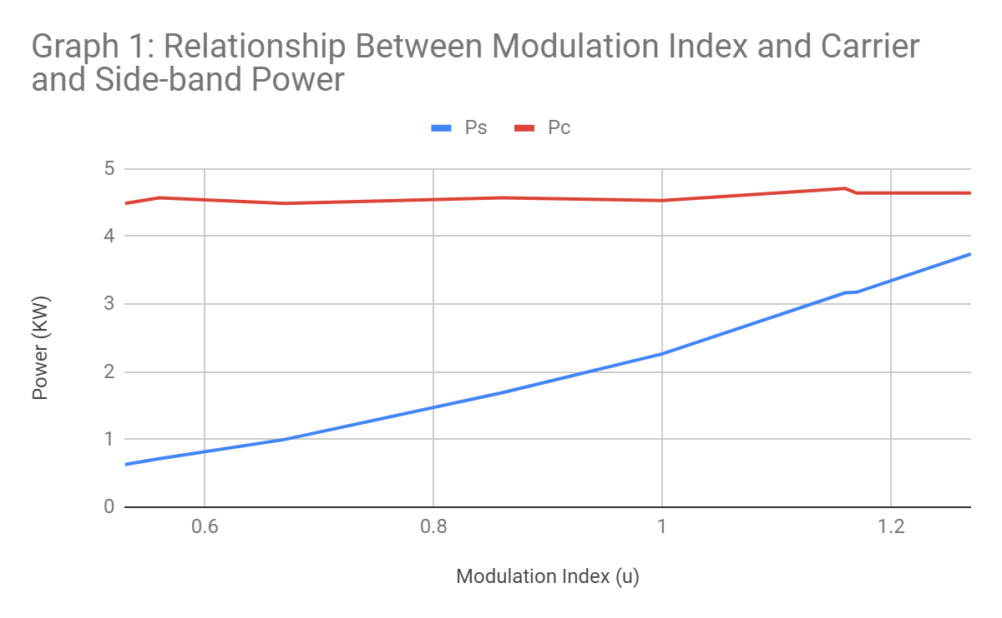

Graph 1: Power (Sideband Power & Carrier Power) vs Modulation Index

The trend depicted in Graph 1 shows that the PC had a mostly constant trend (deviations may possibly be attributed to noise) and PS had a somewhat linear trend. In Graph 2, the trend for Power Efficiency had a linear trend which is reflective of the PS trend in Graph 1.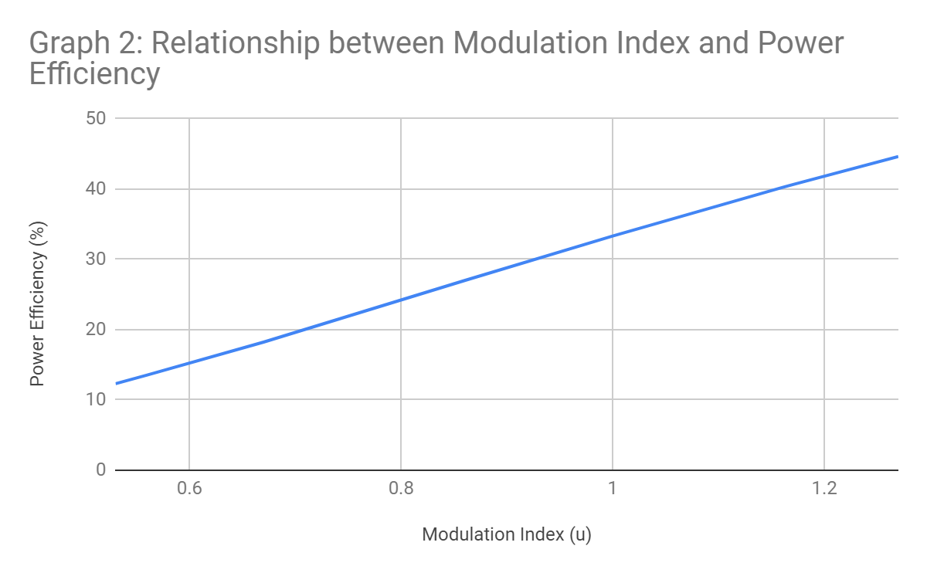

Graph 2: Power Efficiency % vs Modulation Index

**Problem B4:** Having a maximum amount of efficiency while still being able to modulate the signal means that the modulation index must be 1, which in turns makes the power efficiency about 50%. For the modulation index to be 1, both AC and Am have to be equal which means Am and AC are both to be 0.1. This is more vividly seen with the equation $P_{s}=\frac{µ^{2}A^{2}}{4}$, which shows that in order to increase the sideband power, which ensures that the efficiency of the signal is also increased (which can be seen from the $η= \frac{P_{S}}{P_{C}+P_{s}}$ formula), also requires the modulation index to be as high as possible in other words 1. Since AC has already been set to make the modulation index 1, Am must also be 0.1.

**Problem C1:** It is definitely possible to demodulate an AM radio signal even though the positive modulation index is greater than 100% because this value only shows the positive component of a signal that needs to be carried. Of course, the modulation index must be between 0 and 100 percent however, when the modulation index is 100% the positive side can still reach over this value, for example to 125%, and not distort the signal. Similarly, the negative portion of a signal can never reach over 100% because at this point the negative portion will cross over the x axis which causes distortion in the signals.

**Problem C2:** Between the two envelope detectors the that is better to use in practice is the rectifier-based envelope detector. The first reason this is the better option is because it requires less parts to realize and this means it is far less expensive than the Hilbert circuit. Another reason is because the Hilbert Transform is far from ideal and cannot be synthesized as a circuit. It can only be ideal for pure sinusoids, which is also a problem. From this it can be seen that the rectifier envelope detector is a lot better than the Hilbert.

**Problem C3**: The Coherent Detector and the Envelope Detector both demodulate the modulated signal perfectly when the modulation index is approximately 1. However, when this value is decreased by decreasing the amplitude of the modulating signal to about 0.5 the envelope detector begins to fail and output a distorted demodulated signal where as the coherent detector still demodulated the modulated signal properly. The amplitude of the modulating signal was then increased to about 15 Vpp (when the modulation index was about 1.5) and it was seen that at this point both demodulators broke down and neither of them could demodulate the signal properly. This shows that the coherent detector is more efficient than the envelope detector however it is a much more expensive and intricate design.

**Problem C4**: If the PLL (phase locked loop) is replaced with a local oscillator with the same frequency the AM signal can still be demodulated, however the demodulated signal may have some errors. In the case of the PLL, which is a control system that allows the output signal to have the same frequency as the input signal, this will ensure that the correct frequency is used to properly demodulate the signal. In the case that the PLL is switched with a local oscillator the only way that the signal will be properly demodulated is if the frequency of the oscillator and the modulated signal match. Using just PLL results in a demodulated signal with additional spectral components centered around 2wc. This is perfect because the signal can just be filtered, and the original signal can be retrieved. With a local oscillator, in the event that the frequencies do not match, there will be no demodulated signal as both the local oscillator and the demodulator will be completely out of phase. From this it is clear that it is very possible to demodulate the AM signal using a local oscillator however it needs to be ensured that there is no phase difference between the local oscillator and the demodulator. Essentially, the carrier phase found in the local oscillator and the phase of the carrier to demodulate must be exactly in phase, the PLL ensures this, without it demodulation might be impossible.

## Closing Remarks & Practical Applications

Through the successful completion of the Amplitude Modulation and Demodulation lab many insightful observations were made about the course material, specifically AM signals. Some observations that were found include the effects of overmodulation and under-modulation, in most cases it was found that when the signal was over modulated it caused the signal to distort and right signal was not found at the point of demodulation, there were also cases when the signal completely could not be retrieved at all. When the signal was under-modulated the signal distorted. From the 4 methods of calculating the modulation constant it was agreed on that the second method or the one that relied on the trapezoidal method was the best as it gave the most accurate results. The trapezoidal method was the easiest way to find the parameters to calculate the modulation index as well, it gave the least amount of error.

Many different techniques of demodulation were also used, this included a rectifier-based envelope detector, a Hilbert transform based envelope detector and a coherent detector. It was found that all these methods had their own positive points and negative points. For example, the Hilbert transform demodulated the signal perfectly, however in reality the circuit is very difficult to synthesize, and this also means it is very expensive. The rectifier-based demodulation would be the cheapest, because it requires the least amount of material, and still gets the job done properly. However, this does not mean it is perfect, it was also found that in comparison to the coherent detector it distorted the signal at a rather low amplitude for the modulating signal. From this the coherent detector might be the best of the 3 as it is relatively cheap, it can be realized in theory and practically and it is able to withstand the pressures of over modulating better. Many other theoretical aspects of the AM signal were also learned through the post lab discussion questions which can be seen above this section.

Although this lab was incredibly successful, there were a few sources of errors that may have skewed the results. One possible source of error may be noise that the modulating signal would carry when being amplitude modulated and finally demodulated. Of course, this is an error caused by faulty wires and equipment. Another source of error might arise from measuring errors, this can easily happen because the knobs on the oscilloscope are sensitive and even with the best of care the measurements may come out slightly different than the actual value. This can be fixed next time by taking three measurements instead of 1 at different times and averaging them. Round errors may have also skewed the final results. It was found that the modulation index was expected to be the value of the amplitude divided by 10 approximately. This however was not the case at smaller amplitudes. This may have occurred because of rounding in the calculations. Although these are small they may have skewed the results slightly.

Amplitude Modulated signals have many practical uses, the most common being AM radio which is exactly what the name says, amplitude modulated radio. A lot of radio channels in Canada rely on AM, the major reason is because of its effective ways of transmitting and the machinery used in radios to demodulate is inexpensive. Another important practical use is QAM or quadrature amplitude modulation which is a modified version of AM and is used in Wi-Fi and cellular communications. This lab gave insight on one of the most broadly used signal transmission methods.